Tag Battle

Tag Battle is a two-player interactive game where players compete in a digital version of tag. Each player controls a colored character that can move around a map using keyboard controls. When one player’s circle touches the other, the tagger’s color changes, and the timer resets. The goal is to stay not tagged for as long as possible.

- Some cool features I will add are power-ups and also traps that stop players from moving for a certain amount of time.
- I can also have many different characters and let people choose which one they want in the beginning.
- Adding teleporters and jump pads as well

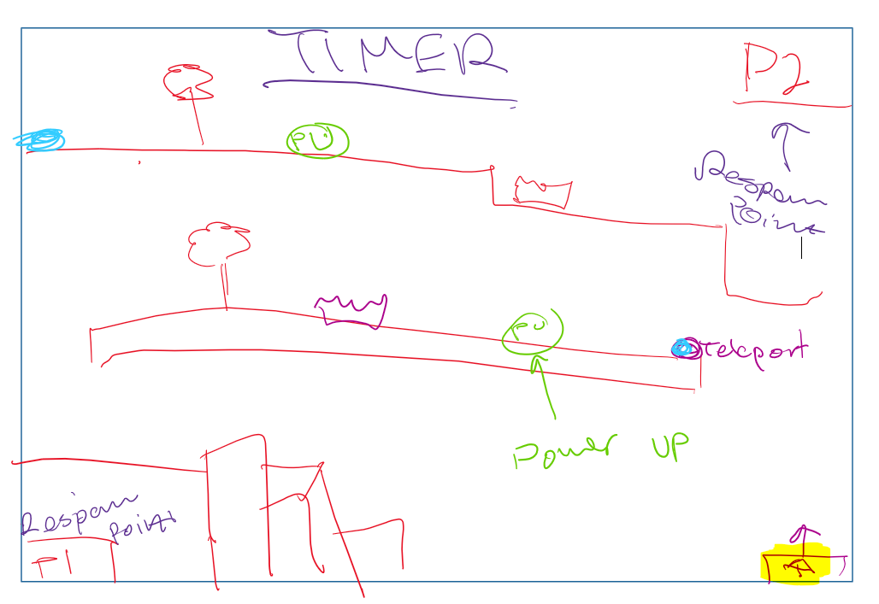

Project Proposal: Taskly
Overview:
Taskly is an interactive task manager built in Processing that transforms productivity into play. Instead of plain checkboxes, users complete daily tasks to earn points, feed a virtual pet, and unlock new evolutions. The program blends organization with simple game mechanics, making productivity feel rewarding rather than repetitive. It’s designed for kids—or anyone who wants to make their schedule feel more alive.
Core Features:
- Custom Task Creation: Users can type new tasks, assign time limits, and mark them complete.
- Interactive Interface: Each task appears in its own animated box, visually aligned to form a personalized schedule.
- Gamified Progress: Completing tasks grants points that can be used to feed a virtual pet, causing it to grow or evolve.
- Pet Evolution System: The pet evolves through several stages based on the user’s productivity.
- Spin Wheel Mini-Game: After completing tasks, players can spin a colorful wheel to earn bonus food or points.
Goal:
To design an engaging way to encourage organization, discipline, and fun using creative visual feedback and interactive programming concepts.
Roadmap

Phase 1: Setup and Core Mechanics
- Set up your window and basic layout (size(), background color, etc.).
- Create a basic Task class with properties like title, done, and timeLimit.
- Display a few test tasks on screen using rectangles and text.
- Implement mousePressed() to toggle tasks on/off.

Phase 2: Add Game Elements
- Add a simple Pet class with a few “growth stages.”
- Display the pet and have it grow when tasks are completed (based on points).
- Add points logic: each task completed gives a certain amount of points.

Phase 3: Interactivity & Animation
- Animate task boxes (like a bounce when checked).
- Add the spin wheel feature using randomization and rotation math.
- Create a “reward” system tied to the spin results (extra food, points, etc.).

Phase 4: UI Polish and User Input
- Implement a simple text input or button-based task adder.
- Improve visuals with PImage, custom colors, and transitions.
- Add sound effects or background music 1111111111111111111111111111111111111111111

Phase 5: Refinement & Extra Features
- Add file saving (saveStrings, loadStrings)
- Optimize code with functions and organized classes.
- Polish animations, fix bugs, and finalize visual design.

Journal

11/4
Goals: Finalize project proposal, and what game I am going to make

Today I accomplished finishing my project proposal and finalizing my project idea (Taskly). I have started to do a little bit of broad coding and setting it up.

I had problems deciding whether to do a fun or practical project for my coding game. Weighing and choosing both sides was particularly hard and doing the first few steps to get the code up and running was challenging as well.

Notes: Start going into the coding process -- finalize more details for Taskly and a gist of how. It is going to work

11/6
Goals: Continuing programming, start working on classes and functions → get ⅕ of the way done with drafting stage

Today I finished a moused pressed function, and added booleans

I had problems getting the moused pressed function to work in the beginning, and also how to connect the mouse pressed with my boolean functions

Notes: Continue with coding -- start working on the spinny wheel and different unique designs for pets and how they should grow

